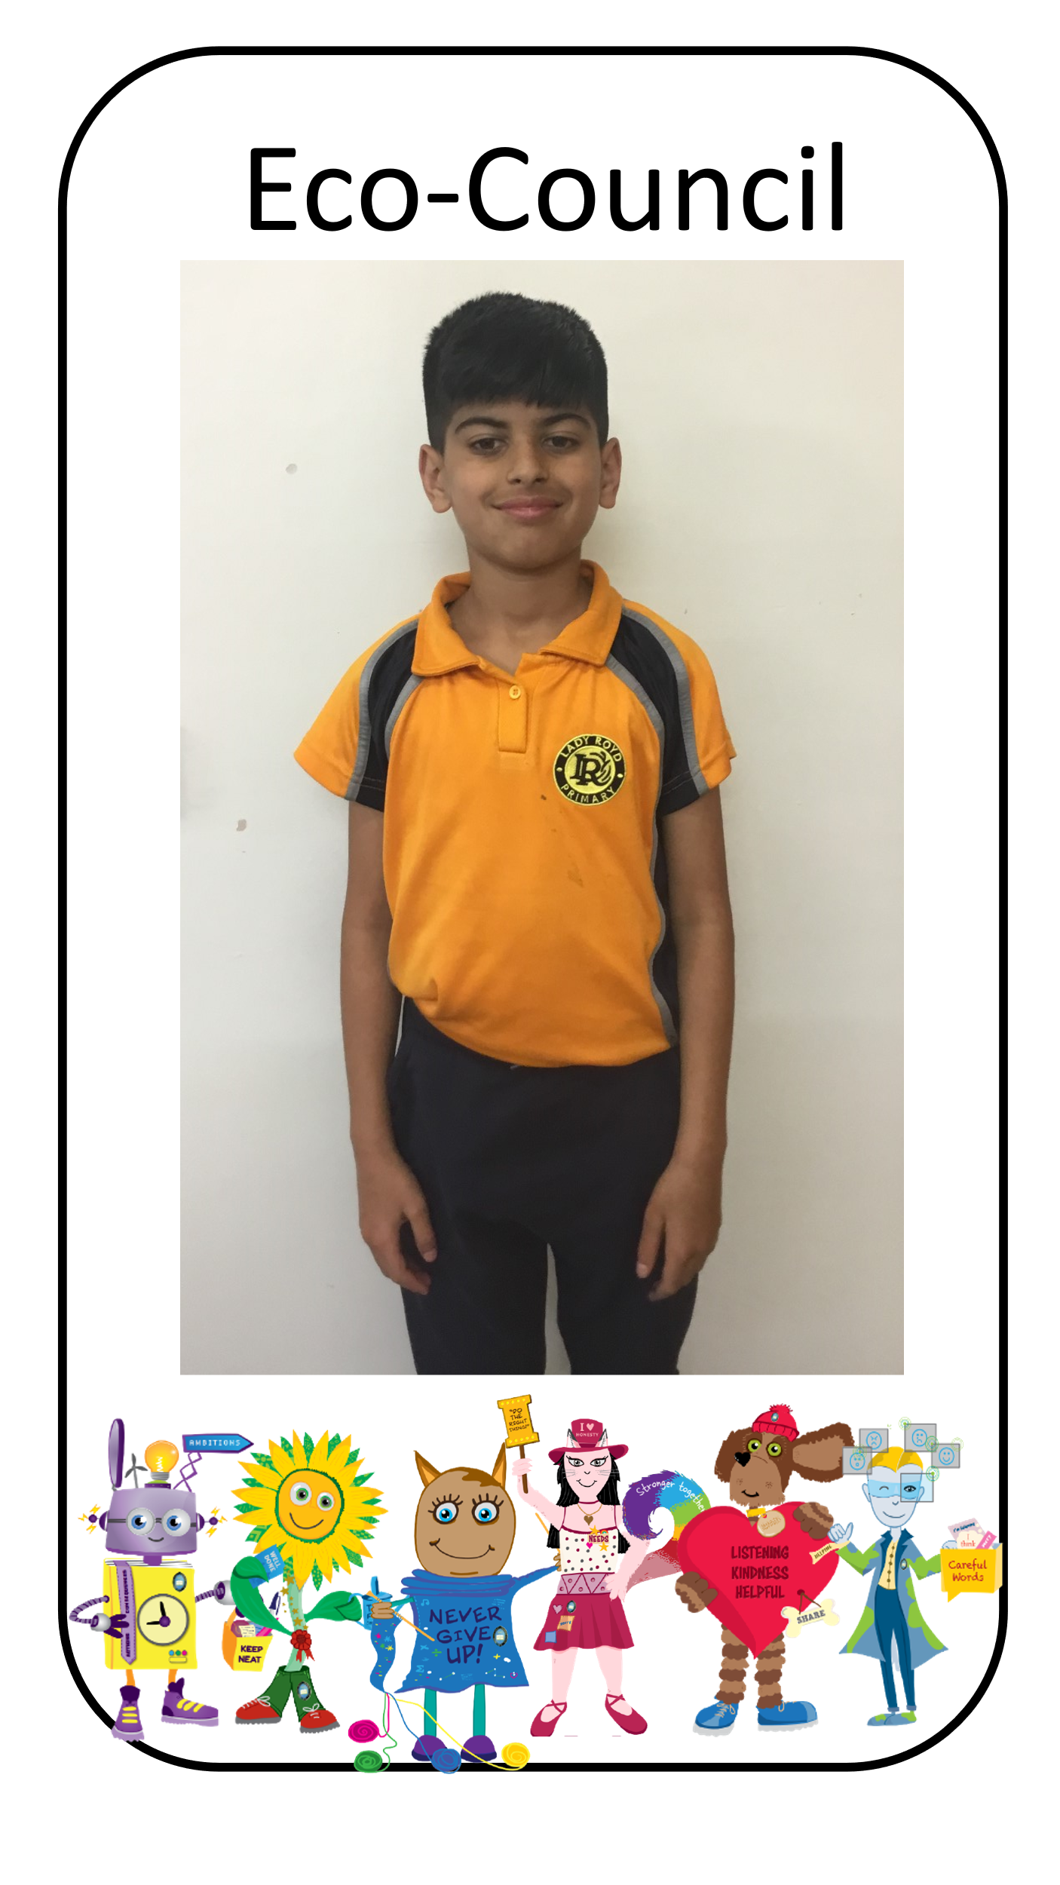
Meet some of our Eco-Councillors:
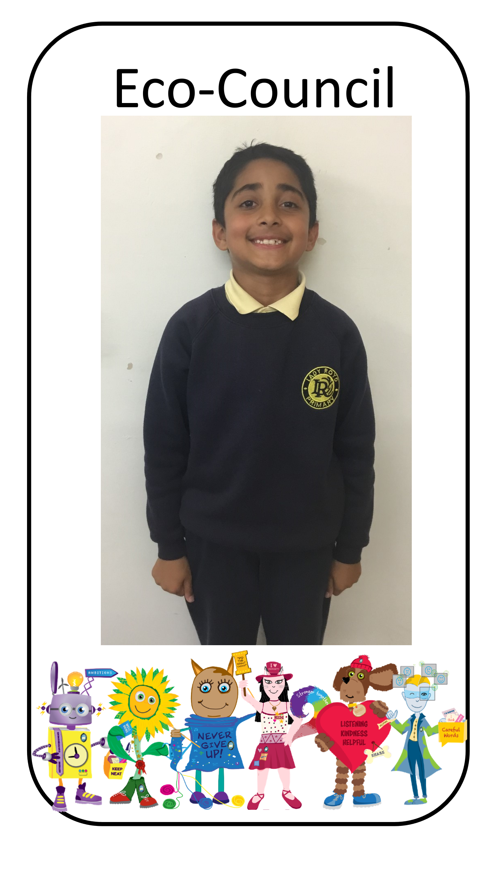

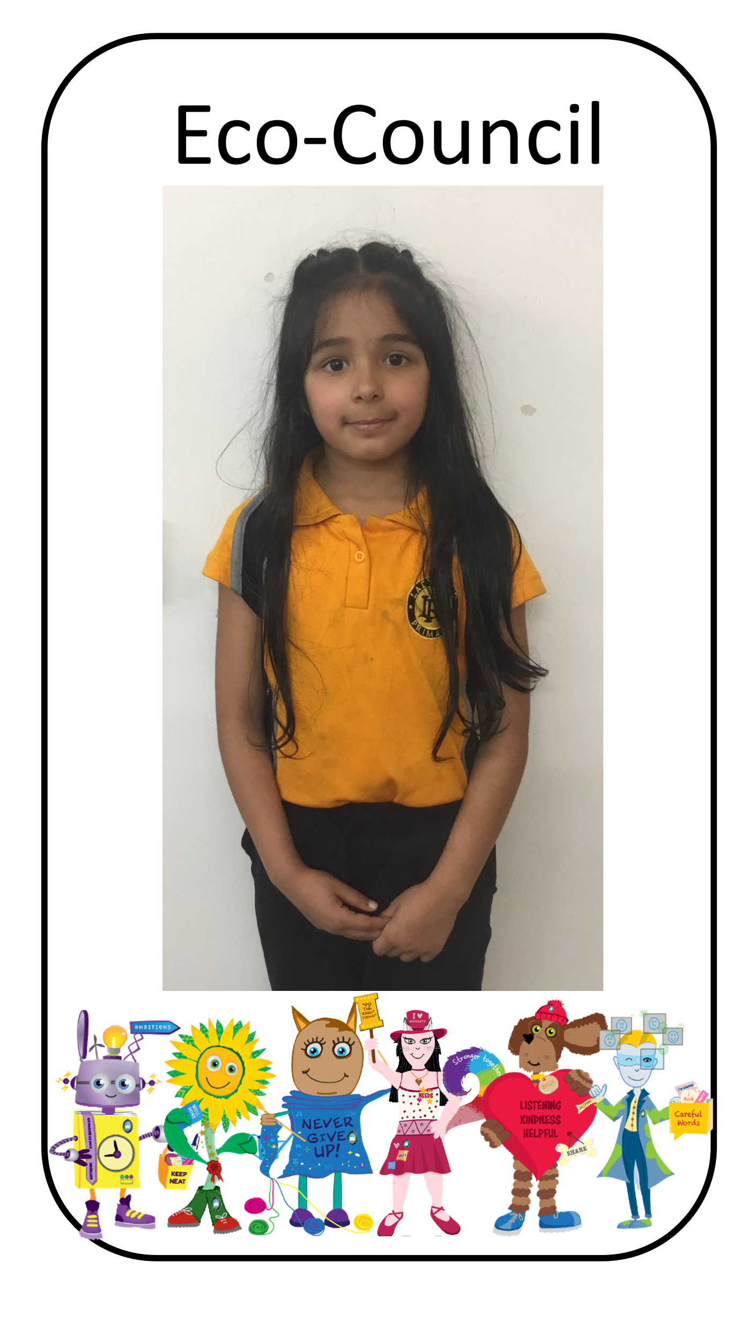
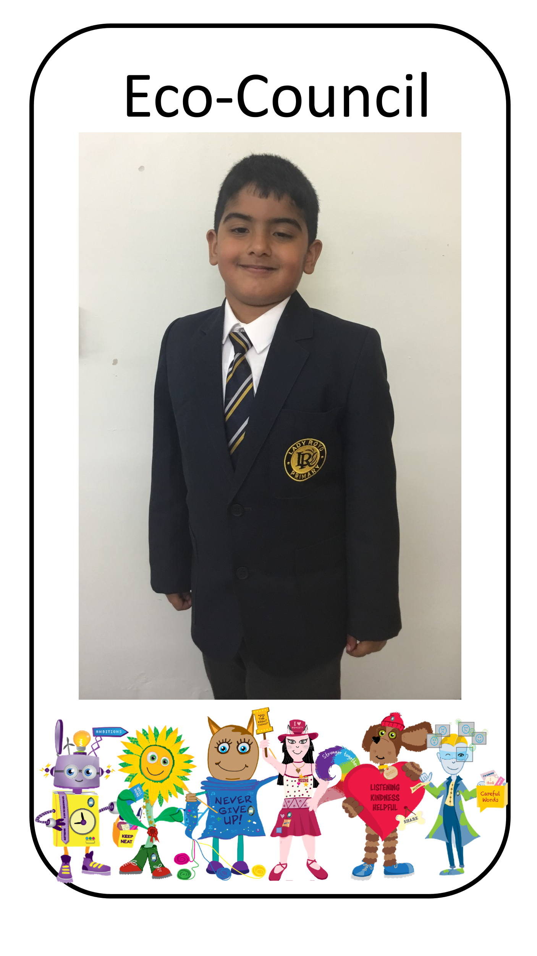

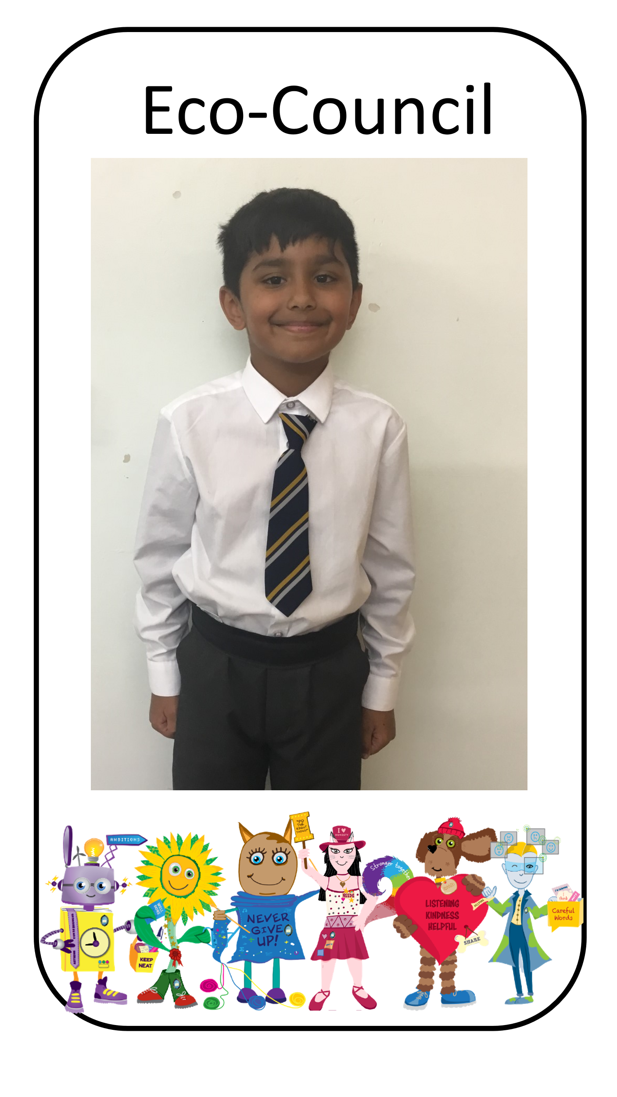

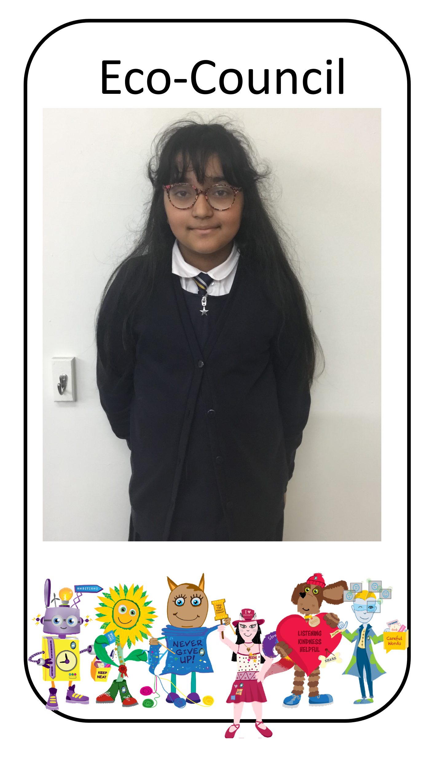

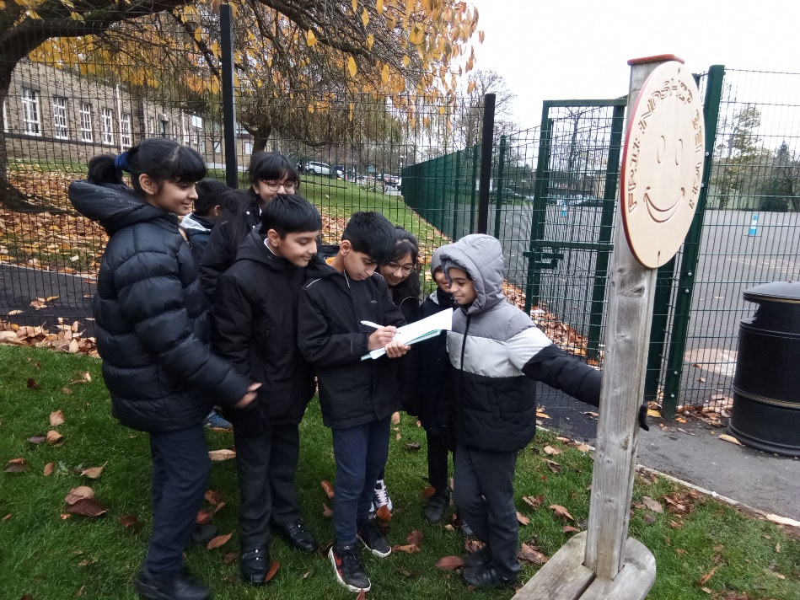
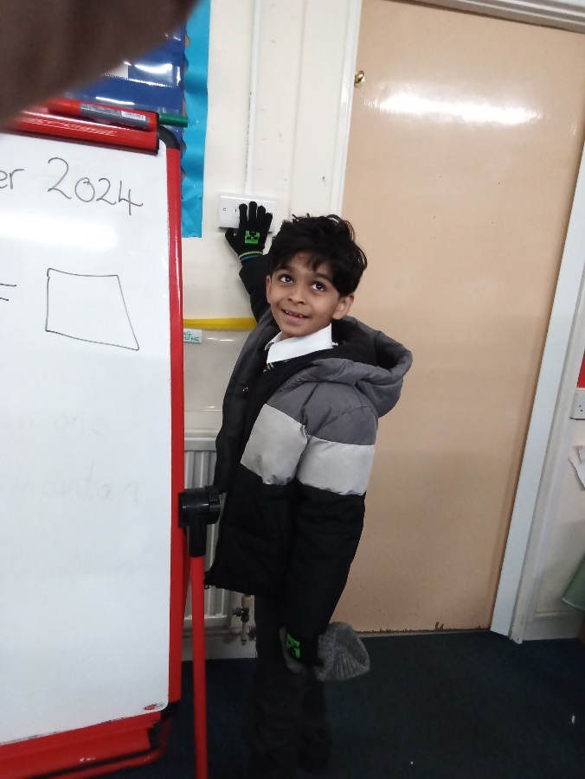
This academic year, our Eco-Council has been committed to making our school a more environmentally friendly place. We started with an audit to evaluate how ‘green’ our school was. This helped us identify key areas for improvement and set clear priorities for action.
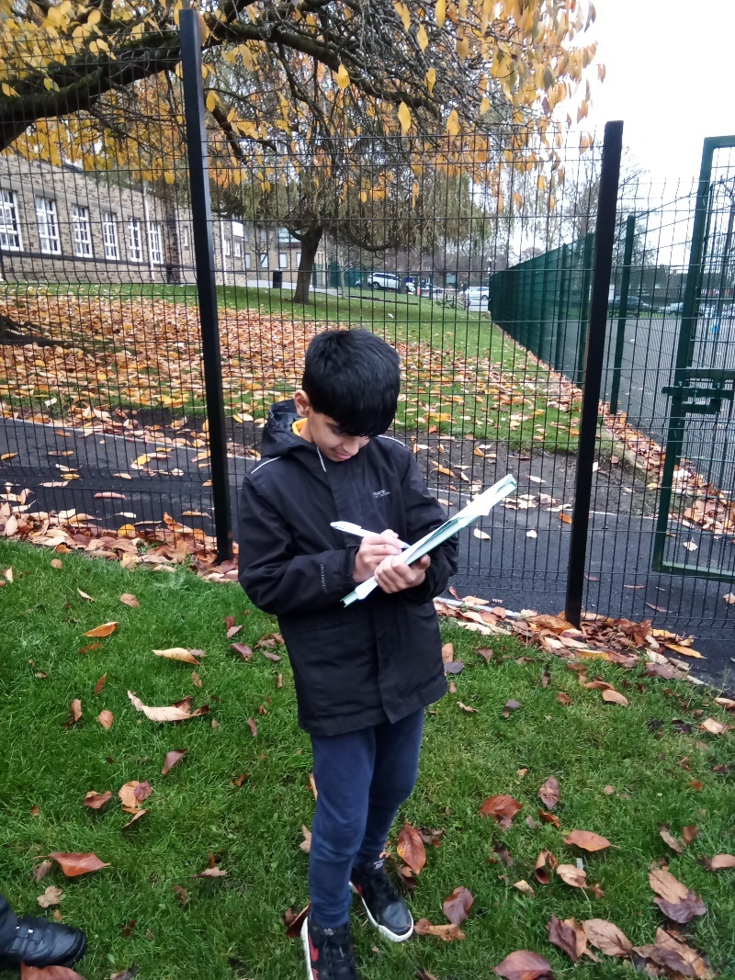

Before making any changes, we knew it was important to inspire our school community. The Eco Council’s first task was to spread awareness about environmental issues. They did this by designing posters to highlight key environmental issues and encourage eco-friendly habits. They also delivered a school assembly focusing on what we can do to collectively protect our environment. We encouraged every class to discuss ideas (during one of their class assemblies) on how to improve the environment ( home, school and community).
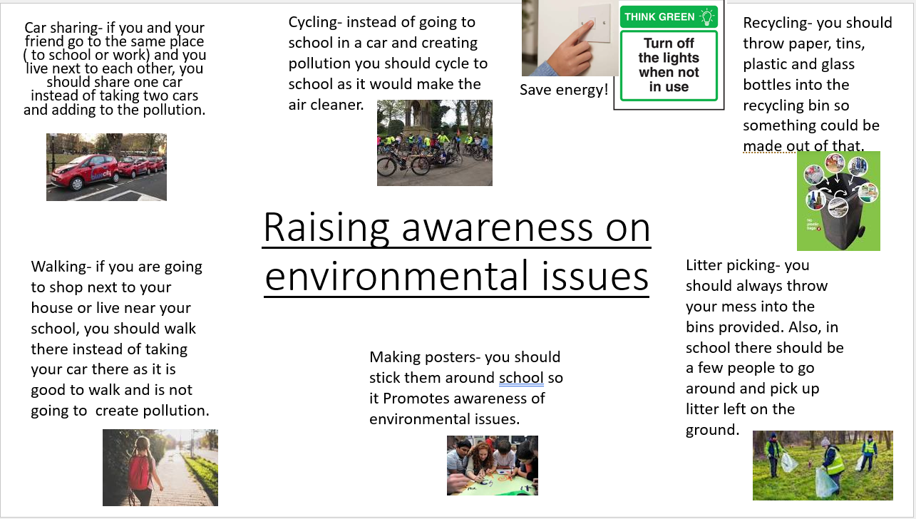

Following our awareness campaign, the Eco-c0uncil have taken action to reduce waste and improve recycling. We have introduced recycling boxes/bins for each class.
